Appendix 6

FORM OF FRONT OF NOTICE OF EXEMPTION IN ENGLAND AND SCOTLAND

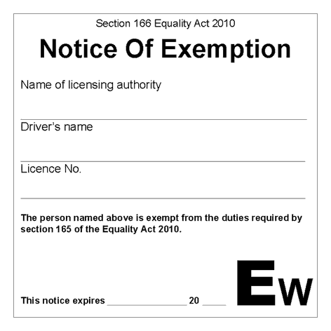

FORM OF BACK OF NOTICE OF EXEMPTION IN ENGLAND AND SCOTLAND
